

FUFO_VP
Software Architecture

Project Code: FUFO_VP
Document Code: FUFO_VP_SAD– v1.0.1

Ha Noi, March 10th , 2012

Record of change

*A - Added M - Modified D - Deleted
Effective Date | Changed Items | A*  M, D | Change Description | New Version
2012/03/10 | Introduction | A | Add introduction | 1.0.1

SIGNATURE PAGE

ORIGINATOR: NguyenLK March 10th, 2012
Team Leader

REVIEWERS: <Name> <Date>
<Position>

<Name, if it’s needed> <Date>
<Position>

APPROVAL: <Name> <Date>
<Position>
TABLE OF CONTENTS
1 Introduction 3
1.1 Purpose 3
1.2 Scope 3
1.3 Definitions, Acronyms and Abbreviations 3
1.4 References 3
1.5 Overview 3
2 Architectural Representation 3
3 Architectural Goals and Constraints 3
4 Use-Case View 3
4.1 Use-Case Realizations 3
5 Logical View 3
5.1 Overview 3
5.2 Architecturally Significant Design Packages 3
6 Process View 3
7 Deployment View 3
8 Implementation View 3
8.1 Overview 3
8.2 Layers 3
9 Data View (optional) 3
10 Size and Performance 3
11 Quality 3
12 Other Considerations 3

Introduction

Purpose
This document helps developers understand more clearly about FUFO system. It is also used by customer to review all functions more evidently to prevent misunderstanding of developers about system. Moreover, it is used for integration test, all functions have to map with this document.

Scope
This document describes architectural design guidelines and requirements for the VP module. This includes user functional and non-functional requirements, business use-cases, and software layering approach, technology and software requirements, and external interfaces to other systems.

Definitions, Acronyms and Abbreviations
Acronym | Definition | Note
SAD | Software Architectural Document
AOP | Application on phone
AOC | Application on computer
FUFO | FPT University Flying Object | Controlled by AOC through AOP

References
N/A

Overview
The content of this SRS is organized as follow:
- Section 1 is a general introduction to this document.
- Section 2 is an architectural representation to describe the general factors that affect the products and its requirements.
- Section 3 is an architectural goal and constraints.
- Section 4 is use – case view.
- Section 5 is logical view
- Section 6 is process view
- Section 7 is implementation view
- Section 8 is data view
- Section 9 is size and performance
- Section 10 is quality
- Section 11 is other consideration

Architectural Representation
[This section describes what software architecture is for the current system, and how it is represented. Of the Use-Case, Logical, Process, Deployment, and Implementation Views, it enumerates the views that are necessary, and for each view, explains what types of model elements it contains.]
This VP system uses architect client - server to communicate between AOP and AOC. It uses TCP/IP protocol to control command and status between AOP and AOC. We need securely We will describe more clearly on following section.

Architectural Goals and Constraints
[This section describes the software requirements and objectives that have some significant impact on the architecture, for example, safety, security, privacy, use of an off-the-shelf product, portability, distribution, and reuse. It also captures the special constraints that may apply: design and implementation strategy, development tools, team structure, schedule, legacy code, and so on.]

Use-Case View

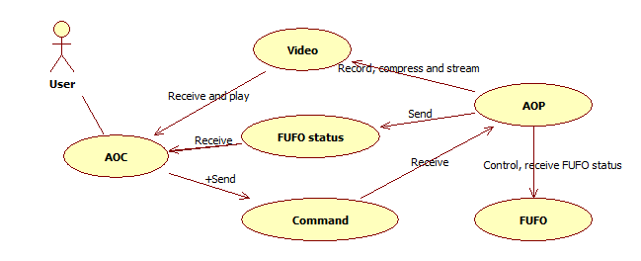

Use-Case Realizations
[This section illustrates how the software actually works by giving a few selected use-case (or scenario) realizations, and explains how the various design model elements contribute to their functionality.]

Logical View

Overview
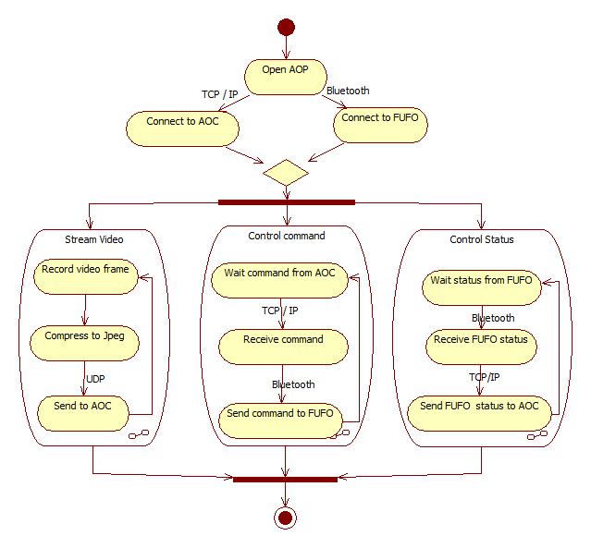

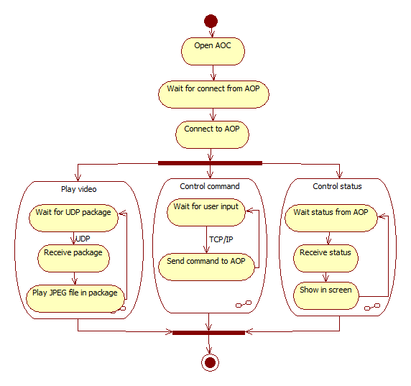

Architecturally Significant Design Packages
[For each significant package, include a subsection with its name, its brief description, and a diagram with all significant classes and packages contained within the package.
For each significant class in the package, include its name, brief description, and, optionally a description of some of its major responsibilities, operations and attributes.]

Process View
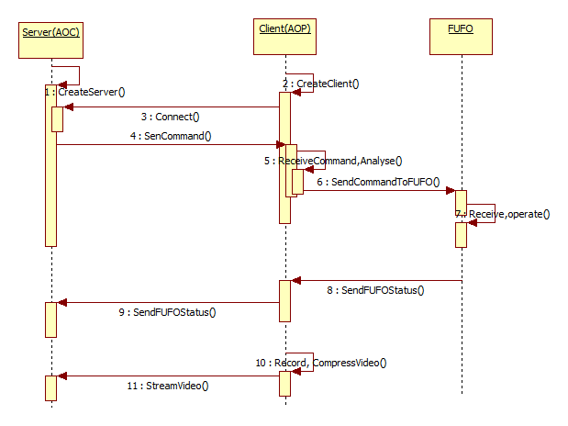
[This section describes the system's decomposition into lightweight processes (single threads of control) and heavyweight processes (groupings of lightweight processes). Organize the section by groups of processes that communicate or interact. Describe the main modes of communication between processes, such as message passing, interrupts, and rendezvous.]

Deployment View
[This section describes one or more physical network (hardware) configurations on which the software is deployed and run. At a minimum for each configuration it should indicate the physical nodes (computers, CPUs) that execute the software, and their interconnections (bus, LAN, point-to-point, and so on.) Also include a mapping of the processes of the Process View onto the physical nodes.]

Implementation View

Overview

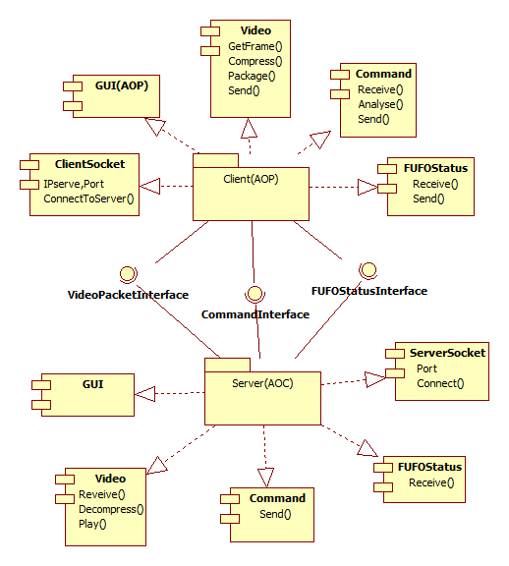

Layers
[For each layer, include a subsection with its name, an enumeration of the subsystems located in the layer, and a component diagram.]

Data View (optional)
[A description of the persistent data storage perspective of the system. This section is optional if there is little or no persistent data, or the translation between the Design Model and the Data Model is trivial.]

Size and Performance
[A description of the major dimensioning characteristics of the software that impact the architecture, as well as the target performance constraints.]

Quality
[A description of how the software architecture contributes to all capabilities (other than functionality) of the system: extensibility, reliability, portability, and so on. If these characteristics have special significance, for example safety, security or privacy implications, they should be clearly delineated.]

Other Considerations
[This section provides a description of other approach/ solutions that were considered in selection process for the above architecture, i.e. a brief explanation of advantages and disadvantages of the selected architecture in comparison with others. It should be a clear answer to the question why the above architecture is selected for this system, not the others.]

